**<http://docs.unity3d.com/540/Documentation/Manual/class-WorldParticleCollider.html>**

**World Particle Collider (Legacy)**

**世界粒子碰撞器（旧版）**

The **World Particle Collider** is used to collide particles against other Colliders in the scene.

世界粒子碰撞器用来检测与场景里其他碰撞器的碰撞

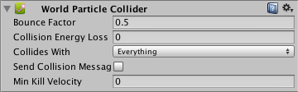

**Properties**

**属性**

| ***Property:*** | ***Function:*** |
| --- | --- |
| **Bounce Factor**  **反弹因素** | Particles can be accelerated or slowed down when they collide against other objects. This factor is similar to the **Particle Animator’s Damping** property.  粒子在碰撞其他碰撞器时可以加速或减慢。这个因素类似粒子动画的阻尼特性 |
| **Collision Energy Loss**  碰撞能量的减少 | Amount of energy (in seconds) a particle should lose when colliding. If the energy goes below 0, the particle is killed.  一个粒子当碰撞时，他的能量应该减少。如果能量小于0，粒子消失 |
| **Min Kill Velocity**  最小消灭速率 | If a particle’s **Velocity** drops below **Min Kill Velocity** because of a collision, it will be eliminated.  如果一个粒子因为碰撞，速度下降低于该值，它会被剔除 |
| **Collides with** | Which [Layers](http://docs.unity3d.com/540/Documentation/Manual/Layers.html) the particle will collide against.  粒子相对碰撞的层 |
| **Send Collision Message**  **发送碰撞消息** | If enabled, every particle sends out a collision message that you can catch through scripting.  如果启用，每个粒子发出一个碰撞消息，你可以通过脚本捕获。 |

**Details**

**详情**

To create a Particle System with Particle Collider:

创建一个带有粒子碰撞器粒子系统

1. Create a Particle System using **GameObject > Create General > Particle System**
2. 使用菜单**GameObject > Create General > Particle System** 创建一个粒子系统
3. Add the **Particle Collider** using **Component > Particles > World Particle Collider**
4. 使用菜单 **Component > Particles > World Particle Collider** 增加粒子碰撞器

**Messaging**

**消息**

If **Send Collision Message** is enabled, any particles that are in a collision will send the message **OnParticleCollision**() to both the particle’s **GameObject** and the GameObject the particle collided with.

如果启用了Send Collision Message，任何发生碰撞的粒子将发送消息**OnParticleCollision()**到这两个物体——粒子对象和与粒子相撞的对象。

**Hints**

**提示**

* **Send Collision Message** can be used to simulate bullets and apply damage on impact.
* 发送碰撞消息可用于模拟子弹和运用撞击损坏
* Particle Collision Detection is slow when used with a lot of particles. Use Particle Collision Detection wisely.
* 当使用很多粒子时，粒子碰撞检测会很慢。明智地使用粒子碰撞检测。
* Message sending introduces a large overhead and shouldn’t be used for normal Particle Systems.
* 消息发送会产生大量的开销，不应该用于普通的粒子系统。

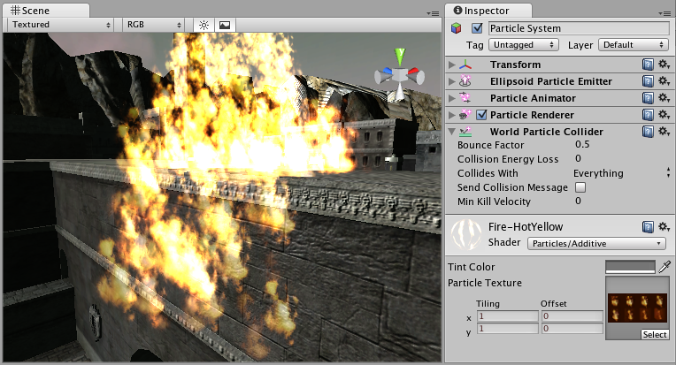

A **Particle System** colliding with a **Mesh Collider**  
一个粒子系统和一个网格碰撞器的碰撞